WASHINGTON STATE UNIVERSITY
Institutional Animal Care and Use Committee

Appendix B: Sample Representative Body Condition Scoring (BCS) Charts for Rodents (See Policy #8 for details)

 | MICE |  | RATS
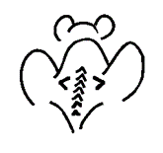 | BC 1  Mouse is emaciated  - Skeletal structure extremely prominent, little or no flesh cover  - Vertebrae distinctly segmented |  | BC 1  Rat is emaciated  - Segmentation of vertebral column prominent if not visible  - Little or no flesh cover over dorsal pelvis, pins prominent if not visible  - Segmentation of caudal vertebrae prominent
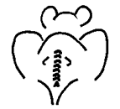 | BC 2  Mouse is under-conditioned  - Segmentation of vertebral column evident  - Dorsal pelvic bones are readily palpable |  | BC 2  Rat is under-conditioned  - Segmentation of vertebral column prominent  - Thin flesh cover over dorsal pelvis, little subcutaneous fat, pins easily palpable  - Thin flesh cover over caudal vertebrae, segmentation palpable with slight pressure
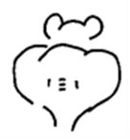 | BC 3  Mouse is well-conditioned  - Vertebrae and dorsal pelvis not prominent, palpable with slight pressure |  | BC 3  Rat is well-conditioned  - Segmentation of vertebral column easily palpable  - Moderate subcutaneous fat store over pelvis, pins easily palpable with slight pressure  - Moderate fat store around tail base, caudal vertebrae may be palpable but not segmented
 | BC 4  Mouse is over-conditioned  - Spine is a continuous column  - Vertebrae palpable only with firm pressure | 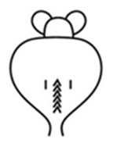 | BC 4  Rat is over-conditioned  - Segmentation of vertebral column palpable with slight pressure  - Thick subcutaneous fat store over dorsal pelvis, pins of pelvis palpable with firm pressure  - Thick fat store over tail base, caudal vertebrae not palpable
 | BC 5  Mouse is obese  - Mouse is smooth and bulky  - Bone structure disappears under flesh and subcutaneous fat | 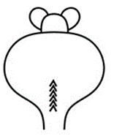 | BC 5  Rat is obese  - Segmentation of vertebral column palpable with firm pressure, may be a continuous column  - Thick subcutaneous fat store over dorsal pelvis, pins of pelvis not palpable with firm pressure  - Thick fat store over tail base, caudal vertebrae not palpable

Appendix C: Representative Scoring System for Determining Humane Endpoints (See Policy #8 for details)

Variable |  |  | Score
Body Weight Changes
0 | Normal
1 | < 10 percent weight loss
2 | 10-15 percent weight loss
3 | > 20 percent weight loss
Body Condition Score (see diagram for details)
0 | Body condition score >3
1 | BCS >2 and < 3
2 | BCS >1 and <2
3 | BCS of 1 or less
Physical Appearance
0 | Normal
1 | Lack of grooming
2 | Rough coat, nasal/ocular discharge
3 | Very rough coat, abnormal posture, enlarged pupils
Measurable Clinical Signs
0 | Normal
1 | Small changes of potential significance
2 | Body temp change of 1-2 ○ C, cardiac and respiratory rates ↑ up to 30%
3 | Body temp change of 1-2 ○ C, cardiac and respiratory rates ↑ up to 50%, or markedly reduced
Unprovoked Behavior
0 | Normal
1 | Minor changes
2 | Abnormal, reduced mobility, decreased alertness, inactive
3 | Unsolicited vocalizations, self-mutilation, either very restless or immobile
Behavioral Responses to External Stimuli
0 | Normal
1 | Minor depression/exaggeration of response
2 | Moderately abnormal responses
3 | Violent reactions, or comatose
 |  | TOTAL:
Note: This scoring template should be modified for specific species and designed to fit each protocol and animal model. In this example, a score is assigned to each variable, 0 (normal or mild) to 3 (severe). The cumulative score gives an indication of the likelihood that the animal is experiencing pain or distress. Humane endpoints can be established based on these criteria. A total score of >5 or a score of 3 in any one variable, regardless of the total score should warrant mandatory evaluation/decision by a veterinarian or humane euthanasia

